Abstract of Topics

Air Quality Monitoring System
Air pollution is one of the most adverse issues in the environment. It causes major effects like cancer, heart diseases and lung diseases etc. Air pollution which is caused by solid, liquid particles and some gases that are present in the air. These particles and gases are evolved by industry, transport, factories. To detect the quality of air, the Arduino based air quality monitoring system is used to monitor the air quality. The buzzer starts beeping whenever the air quality goes below a threshold level, that means a lot of harmful gases are present in the environment such as carbon dioxide, smoke, alcohol, benzene, NH3 and NOx. The quality of air is shown by PPM on the LCD screen. By this the air quality can be monitored easily.

Circuit Diagram
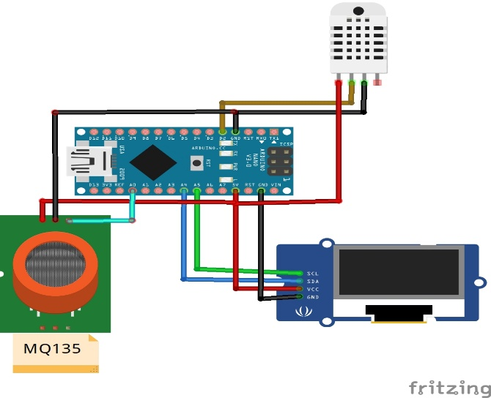

2. Developing an Artificial Pancreas
Imagine if you had to take medicine every time you ate, and you had to use a math formula to figure out how much medicine to take based on the nutritional makeup of the food, how you were feeling, and what activities you were planning to do. You might also need extra medicine throughout the day (even in the middle of the night) based on your blood glucose levels. People with diabetes who take insulin do this every day. They use finger sticks and blood glucose meters or a continuous glucose sensor to monitor their blood glucose throughout the day and take insulin to keep blood glucose within safe levels. Improvements in insulin pump and glucose sensor technology have led to smarter "hybrid loop" systems that can automatically adjust and administer insulin in response to changes in blood glucose levels. Because this type of system attempts to mimic the way the human pancreas works to regulate blood glucose, it is sometimes referred to as an artificial pancreas. In this project you will explore how these systems work by building a circuit that acts as a model of an artificial pancreas using two different liquids (tap water and distilled water instead of insulin and blood). You will try to fine-tune your circuit so it can quickly and safely adjust "blood sugar" to the right levels.
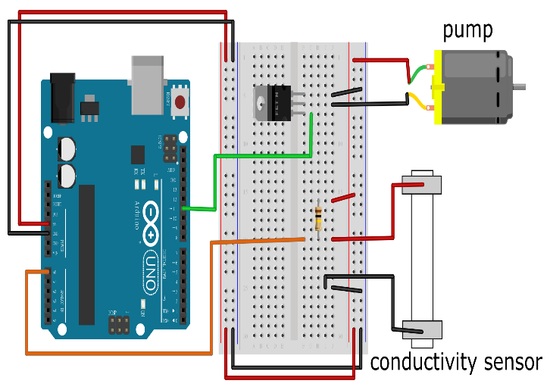

3. Ultrasonic Radar
The application of radio detection and ranging in different places such as military installation, commercial use is done with the help of RADAR SYSTEM which uses electromagnetic waves for detection of different physical components such as distance, speed, position, range, direction, size etc which can be either fixed or be in motion. Use of radar system has been developed greatly specially in field of navigation. In this research we study about existing navigation technologies and proposed an Arduino based radar system. It has advantage over other radar system as kit reduces power consumption and connect programmer to wide range or Arduino programmers and open source code. The system consist a basic ultrasonic sensor placed upon a servo motor which rotates at a certain angle and speed
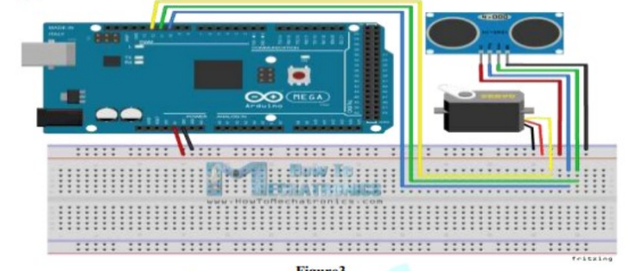

Group Members
- FATHIMA
- YADUKRISHNA
- HEISON
- DOMINIC

